**Executive Summary**

Listerine has been a household name in the U.S. since 1879 when it became the first prescription product in the U.S. to be sold over the counter as a solution to oral germs. Today, it is owned under Johnson & Johnson, one of the world’s largest providers of diverse health products and the leader in oral mouthwash. Using its core competency of antiseptic oral care, it is a prime candidate for introducing a new product in a highly saturated and competitive market such as the Confectionery Market, more specifically, sugar-free gum. Through a full market coverage strategy using different product lines, Listerine can introduce a new sugar-free chewing gum that can offer benefits other gums currently do not have. Over 50% of sugar-free chewing gum users do not believe there is enough gum with oral benefits; however, most consumers agree that sugar-free gum provides fresh breath. Listerine, a leader in oral care, can penetrate the chewing gum market, and meet those needs of the consumer. Innovative packaging and significant marketing will help diversify Listerine’s current product line. It will also leverage dental professionals as it currently does to offer the products to users concerned with oral health care in a new, quicker, and cheaper way. By offering three product lines which include Listerine Chewing Gum, Listerine White, and Listerine Naturals, we believe all of the current needs that consumers seek will be met and the trusted brand of Listerine will grow its market share in an industry that is highly impulse driven.

**Business Description**

* In 1879, Dr. Joseph Lawrence created Listerine mouthwash, a unique antiseptic for use in surgeries and bathing wounds. He was inspired by an English doctor named Joseph Lister who in 1865 became the first surgeon to perform an operation in a chamber sterilized by pulverizing antiseptic in the air. In 1881, Lambert Pharmaceutical Company bought the rights to the Listerine formula and began to produce and market it. In 1914, Listerine became the first prescription product in the U.S. to also be sold over the counter and was marketed as an oral germ killer. Lambert Pharmaceutical Company merged with a company started by William R. Warner which became Warner-Lambert in 1955. This company was subsequently acquired by Pfizer in 2000. Johnson & Johnson then acquired Pfizer’s consumer healthcare division which included major brands such as Listerine, Gillette, Sudafed, and Neosporin in late December 2006 for $16.6B (Listerine website).
* Johnson & Johnson is one of the world's largest providers of diverse health products. The company is engaged in the research, development, manufacture and sale of consumer health care products, pharmaceuticals, and medical devices. J&J has over 230 operating companies in the Americas, Europe, Asia Pacific and Africa. J&J is headquartered in New Brunswick, New Jersey (MarketLine).
* Listerine offers a variety of oral care product lines including mouthwash, fluoride toothpaste, floss, breath strips, breath mist, and READY! TABS. Its products target multiple markets by offering specific benefits including the following:

|  |  |  |
| --- | --- | --- |
| **Product Line** | **Product Type** | **Benefits / Target Markets** |
| LISTERINE Antiseptic Mouthwash | Mouthwash | Kills germs that cause bad breath, plaque, and gingivitis |
| LISTERINE SENSITIVITY | Mouthwash | Provides relief for those with sensitive teeth |
| LISTERINE ULTRACLEAN Tartar Control | Mouthwash | Contains zine chloride that is clinically proven to control tartar buildup |
| LISTERINE NATURALS | Mouthwash | 99% natural formula with no artificial sweeteners or dyes |
| LISTERINE TOTAL CARE | Mouthwash | Prevents cavities, restores minerals to enamel, strengthens teeth, kills bad-breathe germs and freshens breath. |
| LISTERINE HEALTHY WHITE Teeth Whitening | Mouthwash | Whitens teeth and provides 2x stronger enamel than brushing with toothpaste alone |
| LISTERINE ZERO Alcohol-free | Mouthwash | Contains 4 signature essential oils found in Listerine and contains no alcohol |
| LISTERINE FLUORIDE DEFENSE | Mouthwash | Shields teeth from cavity causing acids, rebuilds minerals, and strengthens enamel |
| LISTERINE SMART RINSE for Kids | Mouthwash | Contains the proper amount of fluoride for young teeth and provides cavity protection |
| LISTERINE NIGHTLY RESET | Mouthwash | Used at night prior to bed to remineralize enamel weakened by food and drink throughout the day. Alcohol free. |
| LISTERINE Fluoride Toothpaste | Toothpaste | Fluoride anticavity toothpaste. Prevents cavities, strengthens teeth, and removes stains |
| LISTERINE Floss (Normal, Gentle, Whitening, and Micro-grooves) | Floss | Includes four lines of floss for normal gums, sensitive gums, teeth whitening, and micro-grooves designed to remove 2x more plaque than competitor |
| LISTERINE POCKETPAKS Breath Strips | Mint Strips | Strips placed on tongue that dissolve instantly. Sugar free and kills 99.9% of bad-breath germs. Good for on-the-go. |
| LISTERINE POCKETMIST Breath Mist | Mint Mist | Same as above but in mist form that is sprayed into mouth. Good for on-the-go. |
| LISTERINE READY! TABS Mint Chewable Tablets | Chewable Tablets to Liquid | Chew tablets that turn into liquid. Sugar free and zero alcohol. No information on site regarding killing germs. |

**Environmental Analysis**

Market

* As seen by the table below, the Confectionery Manufacturing Market has reached a mature life cycle stage with high competition.
* For sugarless gum only, sales are stuck at approximately $2.9 billion and are anticipated to drop to just over $2.8 billion at the completion of 2019. The trend is expected to fall through 2023 to approximately $2.3 billion. (Mintel Reports: Chewing Gum)
* Per Statista, 173.4 million people in the U.S. chewed all types of chewing gum in 2018. Of those, approximately 82.9 million chewed sugarless gum. (Statista)

*The following “Industry Structure” covers the Confectionery Manufacturing Market which sugar-free gum is inclusive of. (IBIS World)

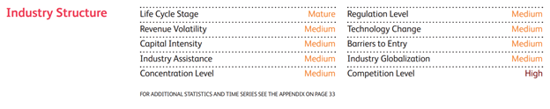

*The following strictly covers sugar-free gum sales in the U.S. (Mintel Reports)

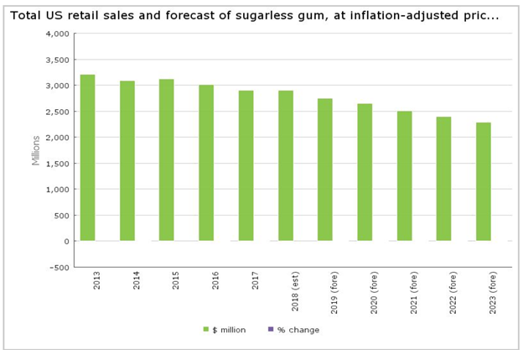

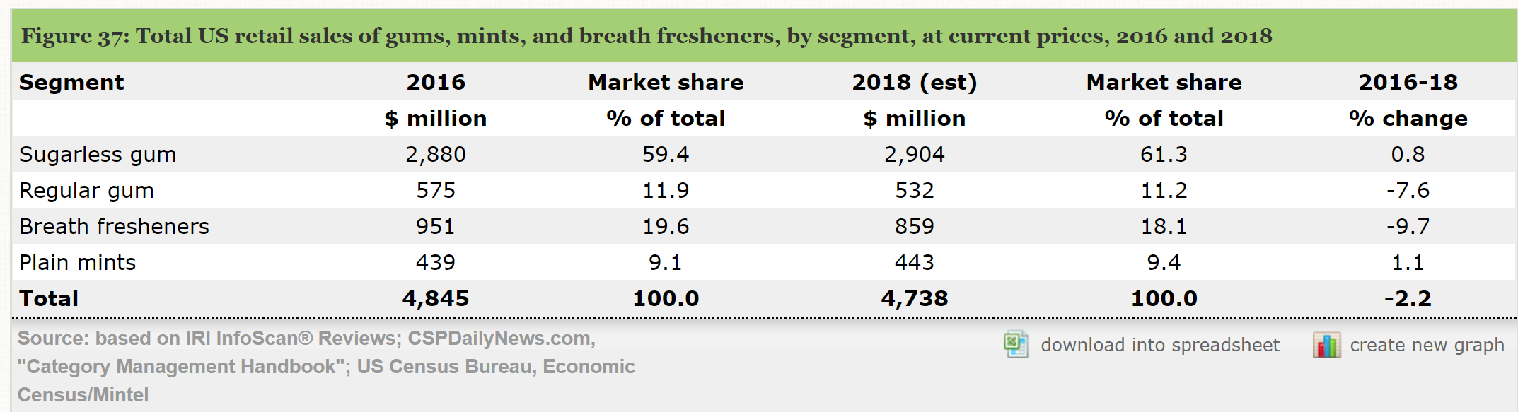

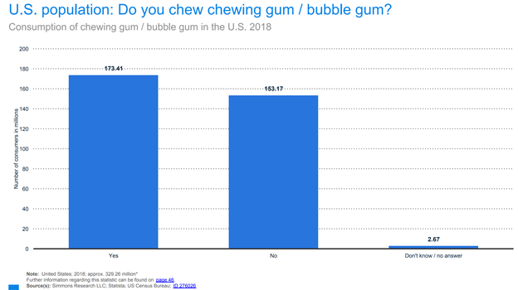

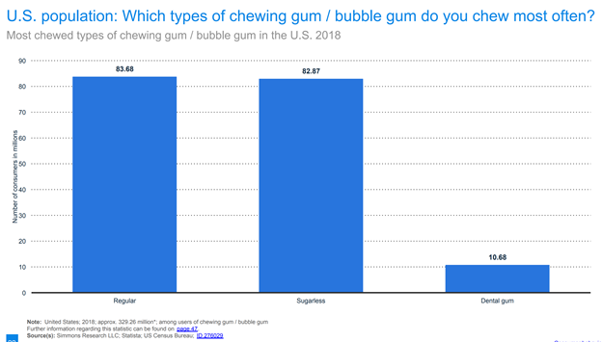

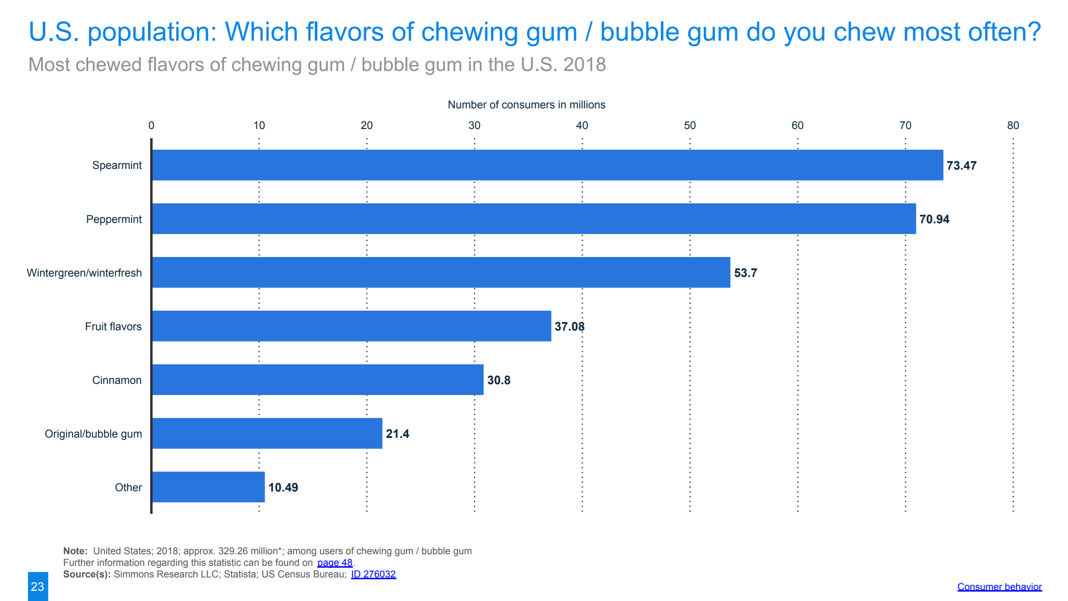

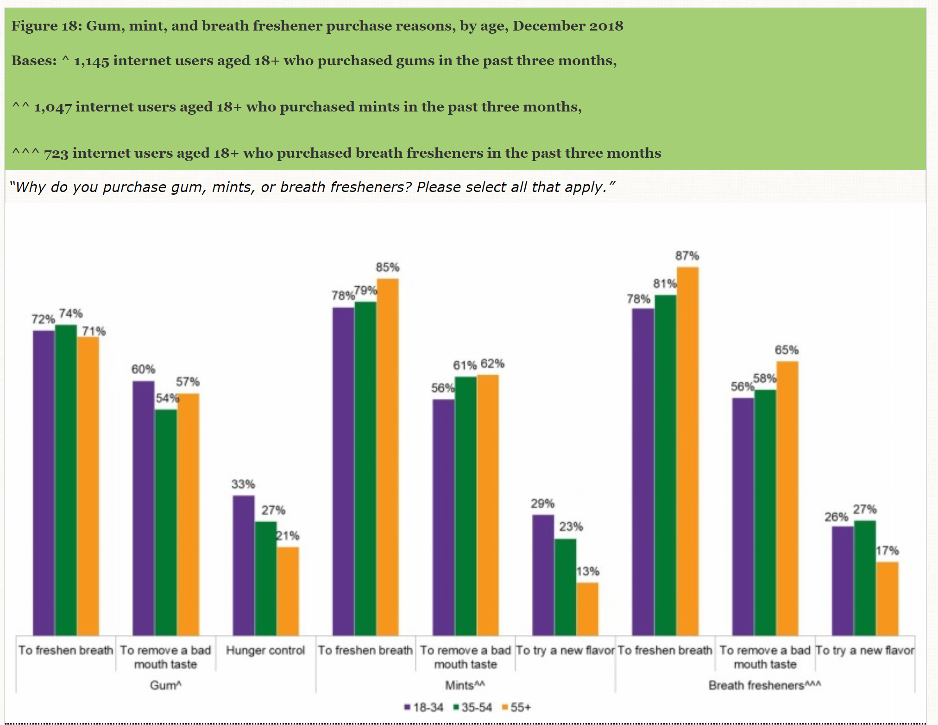

**Competition**

The U.S. chewing gum market currently has four main competitors: Mars, Inc. (Wrigley) (57% market share), Mondelez International Inc. (23% market share), The Hershey Company (9% market share), and Perfetti Van Melle (7% market share). The remaining 4% is covered by all other brands (Statista).

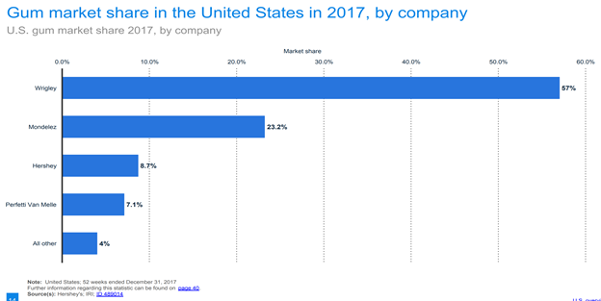

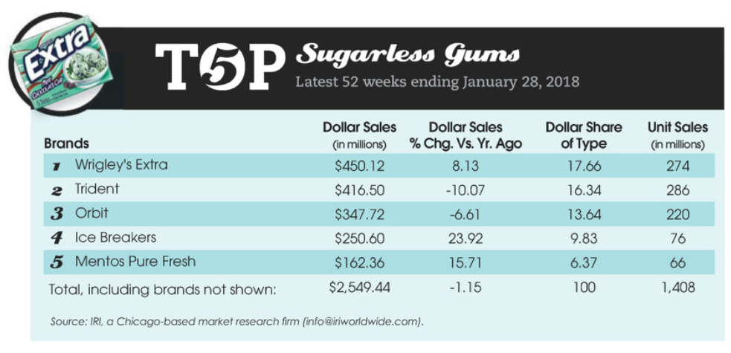

**Mars-Wrigley**

* Wm. Wrigley Jr. Company was founded in 1891 and began manufacturing gum in 1892. In 2008, the company was acquired by Mars, Inc. (MarketLine). Today, the Mars Wrigley confectionary segment is the largest producer of chewing gum in the world (IBIS world). The segment also sells hard candies (including Skittles) and mints to confectionary wholesalers and mass merchandisers. The company produces some of the most recognizable brand names in the world including Wrigley’s Extra, 5 Gum, Orbit, Lifesavers, Juicy Fruit, Big Red, and many others. Sales of Wrigley’s 5 Gum brand and sugar-free chewing gums have been particularly strong due to shifting consumer tastes. For the U.S. candy production industry only, 2018 revenues are estimated at $3.3 billion with profit margins of $534 million. The company’s massive economies of scale in production, distribution, and its brand name recognition have helped it sustain its high profit margins (IBIS world).
* SWOT Analysis (MarketLine)
  + Strengths: Strong Brand Equity, Wide Geographical Presence, Strong Innovation Capabilities
  + Weakness: Lawsuits
  + Opportunity: Increase in Global Food Consumption, Growing Confectionery Market in the U.S., Increase in Consumer Spending in the U.S.
  + Threat: Intense Competition, Stringent Regulations by the FDA, Rising Labor Wages in the U.S.
* Overall, there are approximately 11 different brands of chewing gum Mars-Wrigley offers. Each one also has variations depending on the target market.
* Wrigley’s Spearmint
  + Markets itself as the original Wrigley’s gum since 1893; not sugar-free; spearmint flavor
  + Target: General / older population
* Wrigley’s Doublemint
  + Markets itself as having a “unique” mint flavor that is “perfectly sweet”; no artificial flavors; not sugar-free
  + Target: General population
* Freedent
  + Non-stick chewing gum for people with dental work; sugar-free
  + Target: People with dental works
* Big Red
  + No. 1 selling cinnamon chewing gum since 1987; flavor recently improved for long lasting taste; not sugar-free
  + Target: People who prefer cinnamon flavor gum
* Winterfresh
  + Mantra is “Ice Cool Breath That Lasts”; top selling gum among teens; sponsored X-Games competition; not sugar-free
  + Target: Teens
* Extra
  + Long lasting flavor; newly introduced Chewy Mints; sugar-free
  + Target: Gum chewers preferring long lasting flavor
  + “Give Extra, Get Extra”
* Orbit
  + “Just Brushed Clean Feeling”; received ADA’s Seal of Acceptance; sugar-free
  + Target: those who prefer dental benefits; parents
* Orbit White
  + Similar to Orbit but proven to remove stains and whiten teeth; sugar-free
  + Target: those who want whiter teeth
* 5 Gum
  + Truth or Dare campaign (gives truth or dare under wrapper); markets as adrenaline / rush gum; “stimulates your senses”; “everybody experiences it differently”; sugar-free
  + Target: teens, young adults, adventure seekers
* Eclipse
  + “incredible fresh breath for on-the-go lifestyle”; crunchy outer shell; sugar-free
  + Target: those who prefer fresh breath with no time
* Juicy Fruit
  + Fun experience for the whole family; sugar-free (also options for non-sugar free); sweeter flavors compared to others
  + Target: families, children
* Pricing is relatively similar for all the brands above with the exception of Freedent, Orbit White, and 5 Gum which offer dental benefits or experiences (in the case of 5 Gum). The average price per unit (piece of gum) for CVS is $0.10 while Walmart is $0.06. Amazon is also within this range.

**The Hershey Company**

* Hershey was established in 1886 when Milton S. Hershey opened the Lancaster Caramel Company in Pennsylvania. While it’s primarily known for its chocolate, in April 2018 it launched a new glitter-sprinkled gum in the U.S. under the Ice Breakers brand. This brand was originally associated with mints in 2010 (MarketLine). Other non-chocolate confectionery brands include Twizzlers, Bubble Yum, and Jolly Ranchers. For the U.S. candy production industry only, 2018 revenues are estimated at $1.4 billion with profit margins of $222 million. The company primarily sells its products to wholesalers and retailers like Walmart, Inc. that then distribute the products to consumers and export markets (IBIS World).
* SWOT Analysis (MarketLine)
  + Strengths: Financial Performance, Distribution and Marketing, R&D
  + Weaknesses: Liquidity Position, Dependence of Limited Customers
  + Opportunities: Acquisition of Pirate Brands, Positive Outlook for Global Confectionery Industry; Launch of New Products
  + Threats: Foreign Currency Risk; Expansion Initiatives by Competitors; Government Regulations
* Ice Breakers Ice-Cube Gum
  + Long lasting flavor; newly launched in 2018; markets product through white unicorn with blue sparkles because the unicorn is a mythological construct for confidence and Hershey wants its customers to “grab life by the horns”; primarily comes in 40 piece bottles but also sells 12-piece packets; ADA seal of approval; explains the chemical xylitol and its benefits on website
  + Pricing is premium at $0.12 per unit at CVS and $0.07 per unit at Walmart / Amazon.
* The following was taken from The Hershey Company’s Form 10-K for FYE 12/31/18 regarding its key customers and marketing strategy (Hershey Company 10-K):
* Key Customers
  + “Our customers are mainly wholesale distributors, chain grocery stores, mass merchandisers, chain drug stores, vending companies, wholesale clubs, convenience stores, dollar stores, concessionaires and department stores. The majority of our customers, with the exception of wholesale distributors, resell our products to end-consumers in retail outlets in North America and other locations worldwide.”
  + “In 2018, approximately 28% of our consolidated net sales were made to McLane Company, Inc., one of the largest wholesale distributors in the United States to convenience stores, drug stores, wholesale clubs and mass merchandisers and the primary distributor of our products to Wal-Mart Stores, Inc.”
* Market Strategy
  + “The foundation of our marketing strategy is our strong brand equities, product innovation and the consistently superior quality of our products. We devote considerable resources to the identification, development, testing, manufacturing and marketing of new products. We utilize a variety of promotional programs directed towards our customers, as well as advertising and promotional programs for consumers of our products, to stimulate sales of certain products at various times throughout the year.”

**Perfetti Van Melle (MarketLine: Perfetti Van Melle):**

* Van Melle was founded in Breskens, Netherlands in 1900. Brothers Michael and Pierre Van Melle came up with the idea of Mentos and began collaborating to make mint. Perfetti was founded in Lainate, Italy.
* The first US office was opened in Massachusetts in the year 1975. In 2001, Van Melle and Perfetti both merged to form Perfetti Van Melle. Mentos then introduced gum in Europe in 2005 and later distributed it all over the world including the US. In 2015, it introduced its new flavor, spearmint.
* Perfetti Van Melle is a subsidiary of Perfetti Van Melle Group B.V. It is a privately-held chewing gums manufacturing company. The company offers various products such as candies, mints, power mints, lollipops, gummies, and chewing gum. It markets its products under various brands such as Mentos, Chupa Chups, Alpenliebe, Big Babol, Daygum, FRISK, Fruittella, GOLIA, HAPPYDENT, Morositas, Sula, Vigorsol and Vivident brands.
* The company offers its products and services in various geographical regions including European Union, Asia, Oceania, the Americas, the Middle East, Africa, and Europe. Perfetti is headquartered in Milano, Lombardia, Italy.
* SWOT Analysis
  + Strengths: Perfetti Van Melle has always given a lot of importance to innovation and Mentos has a number of variants to prove this.
  + Weaknesses: The brand Mentos has a lot of variants and deep presence in the confectionery market which is already filled with candies and chocolates of all types. The parent company Perfetti Van Melle also has multiple brands which are creating a dilution of branding for Mentos.
  + Opportunities: Opportunity in the middle east. Mentos has not yet secured the desired share in the Middle East market, however, the confectionery market there is growing at a CAGR of 4.2% in the frame 2011-2018
  + Threats: Labor costs in the US and intense competition.
* Perfetti Van Melle’s Mentos:
  + Mentos Pure Fresh mint, Pure Fresh Spearmint, Pure Sweet Mint are some of its products that primarily comes in 120-piece packets but also sells 50-piece bottles. It offers qualitative products in different and unique packaging. Mentos has adopted a reasonable [pricing](https://www.marketing91.com/pricing-strategies/) policy and kept its prices suitable for its [target market](https://www.marketing91.com/target-market-find-one/). The inexpensive products offer different flavors along with a good taste and fresh feeling thus keeping its customers happy. The brand also faces severe competition from rival brands and has kept its product prices marginally lower than its competitors. This helps it maintain a [competitive advantage](https://www.marketing91.com/sustainable-competitive-advantage/) (Marketing 91)
  + Pricing is normal at $0.06 per unit at Amazon and $0.05 per unit at Walmart.
* Key Customers
  + Mentos has targeted youth from middle and upper-middle class, and its potential customers are mainly wholesale distributors, chain grocery stores, mass merchandisers, chain drug stores, vending companies, wholesale clubs, convenience stores, dollar stores, concessionaires and department stores. The majority of its customers, with the exception of wholesale distributors, resell its products to end-consumers in retail outlets in North America and other locations worldwide (Marketing 91).
* Market Strategy
  + Mentos is a recognized brand and has adopted several promotional policies to increase its [brand visibility](https://www.marketing91.com/7-business-locations-increase-brand-visibility/) in the market.
  + It has been a part of several sporting events, for instance, it released Brazilian Team Mentos during FIFA World Cup 2014 to show its support to the National Football Team.
  + Mentos has launched commercials with catchy taglines and jingles which stay in the minds of consumers. Most of its ads have a humorous element and some show [people](https://www.marketing91.com/people-marketing-mix/) solving their day-to-day problems after having a Mentos.
  + These ads are shown via television, radio, newspapers, magazines and billboards. Mentos has also used social media to its advantage by launching ads and offering information about its product through [Facebook](https://www.marketing91.com/marketing-strategy-facebook/), [Twitter](https://www.marketing91.com/marketing-mix-twitter/) and [YouTube](https://www.marketing91.com/marketing-mix-youtube/). Some common and popular slogans of Mentos are Stay Fresh; The Freshmaker. (Marketing 91)

**Mondelez International:**

* The company has its origin as National Dairy Products Corporation, formed on December 10, 1923, by Thomas H. McInnerney. The firm was initially set up to execute on a roll up strategy in the then fragmented United States ice cream industry. Through acquisitions it expanded into a full range of dairy products. By 1930 it was the largest dairy company in the United States and the world.
* Mondelez International, Inc. (Mondelez or 'the company') is involved in the manufacturing and marketing of snack food and beverage products. These comprise of biscuits, chocolates, gum and candies, beverages and cheese and grocery items which are primarily marketed under Nabisco, Oreo, LU, belVita, Cadbury, Milka, Toblerone, Trident and Tang, to mention a few.
* The company sells its products to wholesalers, supermarket chains, convenience stores, mass merchandisers, supercenters, gasoline stations, drug stores, club stores, and value stores. Mondelez operates in North America, Latin America, Asia Pacific, Europe, and the Middle East and Africa regions. It is headquartered in Deerfield, Illinois, the US.
* SWOT Analysis
  + Strengths: Diversified product offerings complemented by strong brands.
  + Weaknesses: Liquidity affects the company's business operations.
  + Opportunities: Expansion initiatives enhances its future growth opportunities and expansion plans.
  + Threats: Labor costs in the US and intense competition.
* Products, Pricing, Strategies, Target Markets/Customers (company websites: Trident , Dentyne, Amazon)
* Mondelez Dentyne Ice:
  + Peppermint the most popular flavor; primarily comes in 16 piece packets but also sells 60-piece bottles; ADA seal of approval; explains the chemical xylitol and its benefits on website
  + Pricing is premium at $0.08 per unit at Amazon and $0.06 per unit at Walmart.
* Mondelez Trident White:
  + Peppermint and Spearmint are the most popular flavor; primarily comes in 16-piece packets but also sells 60-piece bottles; ADA seal of approval; explains the chemical xylitol and its benefits on website
  + Pricing is premium at $0.05 per unit at Amazon and $0.04 per unit at Walmart.
* Key Customers
  + “Our customers are mainly wholesale distributors, chain grocery stores, mass merchandisers, chain drug stores, vending companies, wholesale clubs, convenience stores, dollar stores, concessionaires and department stores. The majority of our customers, with the exception of wholesale distributors, resell our products to end-consumers in retail outlets in North America and other locations worldwide.”
* Market Strategy
  + “The foundation of our marketing strategy is our strong brand equities, product innovation and the consistently superior quality of our products. We devote considerable resources to the identification, development, testing, manufacturing and marketing of new products. We utilize a variety of promotional programs directed towards our customers, as well as advertising and promotional programs for consumers of our products, to stimulate sales of certain products at various times throughout the year.”

**Distribution Channels** (Mintel Reports)

* The following chart lists the distribution channels for gums, mints, and breath fresheners at current prices between 2013 and 2018. The channels include supermarkets, drugstores, convenience stores, and other. Other includes supercenters, warehouse clubs, natural food stores, dollar stores, off-price retailers, online retailers, etc. Total sales which includes all gums, mints, and breath fresheners as formally stated was $4.7 billion in 2018.
* The primary distribution channel in 2018 was “Other”. Its market share was 41% or approximately $2 billion.
* The secondary distribution channel in 2018 was “Convenience Stores”. Its market share was 29% or approximately $1.4 billion.
* The tertiary distribution channel in 2018 was “Supermarkets”. Its market share was 21% or approximately $977 million.
* The quaternary distribution channel in 2018 was “Drugstores”. Its market share was 9% or approximately $442 million.

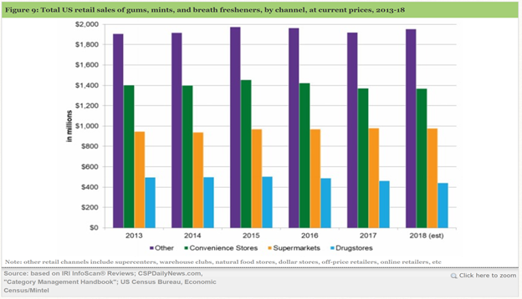

**Five Forces**

* Competitors: Highly competitive as previously explained above.
* Supplier Power (source: MarketLine)
  + Suppliers to this market vary, from farmers and ingredient manufacturers, to the producers of machinery. There is also significant diversity within each supplier category. An example of this is that ingredient producers vary in terms of the ethical standards to which they adhere, the ingredients they offer, or the geographic locations in which they operate. This diversity boosts supplier power, although this is checked by other factors: market players can substitute certain ingredients and employ financial instruments to keep sourcing costs down.
  + Suppliers to this market are cocoa farmers, along with producers of various other raw materials such as sugar, and the machinery required for production and packaging, among others.
  + Manufacturers may also choose to adopt international Fair Trade standards, which ensure that farmers receive a 'fair' price for their products, and that the working conditions are not considered exploitative. As end consumers may opt for Fair Trade certified products over alternatives with weaker ethical credentials, some retailers and market players are compelled to source from Fair Trade suppliers. This further increases supplier differentiation, resulting in supplier power.
  + Despite this, market players do have alternatives: suppliers also exist in other East Asian, West African, and South American equatorial regions, where existing inventory in domestic markets acts as a supply buffer.
  + Major producers, including India, Thailand, and China, were affected by El Nino, experiencing a huge fall in sugar output. This may result in a global rebound of sugar prices going forward which have historically remained low.
  + Raw materials, such as those used by confectionery producers, are bought on commodity markets. While confectionery companies are unlikely to have much control over supplier prices, they are able to hedge in order to reduce the impact of price rises on their margins.
  + Chewing gum primarily includes sugar substitutes and gum base. There are several suppliers for gum bases including Cafosa, Gum Base Co., and Eurobase International.
  + Overall, supplier power is evaluated to be moderate in this industry. (MarketLine)
* Buyer Power (source: MarketLine)
  + Hypermarkets and supermarkets constitute the major buyers in the US confectionery market, accounting for 39% of total sales value in 2018.
  + Buyers such as these exert a strong degree of buyer power, since they control extensive distribution systems, command strong brands, and can drive a hard bargain in negotiations with market players.
  + The confectionery market includes a wide range of product categories, with opportunities for manufacturers to diversify their products from competitors in each segment, such as sugar free snacks or products addressing diabetics. Due to an increase in health awareness, snacks offering health benefits, for instance, with no artificial colors or the inclusion of additives such as vitamins, present new areas of expansion.
  + As most retailers in this market offer a wide variety of products, with confectionery being only a small part of the company’s product range, buyer power is increased. Along with the inherent differences between products in taste and ingredients, among others, manufacturers invest in advertising to build brand identities.
  + This also affects retailers, as consumer preferences compel retailers to respond to demand and stock popular products. Product differentiation and brand loyalty among consumers leads to weaker buyer power.
  + As most retailers in this market offer a wide variety of products, with confectionery being only a small part of their product range, buyer power is increased.
  + Overall, buyer power is assessed as moderate. (MarketLine)
* Threat of Substitution
  + Mints
    - There are multiple mints on the market including but not limited to Altoids, LifeSavers, and Ice Breakers. These can be marketed as freshening one’s breath.
  + Mouthwash
    - Listerine currently has multiple mouthwashes on the market that target users who want fresh breath and better oral care.
  + Toothpaste
    - Toothpastes such as Crest are offering more benefits in one including 3D White.
    - Listerine offers a fluoride toothpaste as well.
  + Breath fresheners
    - Listerine currently offers breath freshening products including Listerine POCKETPAKS and POCKETMIST.
* Threat of New Entry
  + Colgate Gum
    - As the market is saturated and might not have any room for new entry but Colgate can come up with their gum similar to ours and could become an alternate for our product in the market.
    - As Colgate also is a huge brand and develops product for oral and dental hygiene and is having a great customer base which could be a threat of new entry to the market.

**SWOT Analysis**

* Strengths (MarketLine: Johnson & Johnson)
  + Leadership position in diverse healthcare segments.
    - J&J is one of the largest and diversified healthcare companies in the world. It also has strong presence in the medical devices market worldwide. Globally, J&J is the fifth largest pharmaceutical company, and the sixth largest biotech company and consumer healthcare company.
    - Strong market leadership enhances J&J's brand image and enables it to penetrate new markets as new product launches become easier.
  + Strong brand portfolio.
    - The company developed a broad and strong portfolio of brands. At the end of 2016, J&J expects the filing of 10 pharmaceutical products between 2015 and 2019, which generates revenue of $1 billion.
    - Strong portfolio of market leading brands offers a significant source of revenue for the company, thereby providing a competitive advantage over its peers
* Weaknesses (MarketLine: Johnson & Johnson):
  + Legal proceedings.
    - J&J and certain subsidiaries are involved in various claims and lawsuits regarding product liability, intellectual property, commercial and other matters; governmental investigations; and other legal proceedings.
    - Involvement in legal proceedings results in huge financial expenses for the company in the form of fees and penalties. It could also hamper J&J’s reputation in the market if proven guilty.
  + Product recalls may dent J&J's brand image
    - J&J and certain of its subsidiaries are involved in various claims and lawsuits regarding product liability, intellectual property, commercial and other matters; governmental investigations; and other legal proceedings
    - J&J’s Ethicon unit recalled about 14 units of the Sedasys Computer Assisted Personalized Sedation System due to degradation of plastic material of the Sedasys System Control Unit. Such product recalls may dent J&J's brand image besides having a negative impact on its revenue growth.
* Opportunities:
  + Increase in per capita disposable income in the U.S.
    - Per capita disposable income measures an individual’s ability to purchase goods or services. As income rises, consumers are more likely to purchase nonessential goods, such as candy/gum. Per capita disposable income is still expected to increase in 2018, representing a potential opportunity for the industry. (IBIS World)
  + Adding functionality to gum can potentially resonate with consumers
    - Breath freshening is largely considered a given among the category of gum, mints, and breath fresheners. As outlined below, there is significant interest in gums, mints, and breath fresheners that promote dental health and have more functional benefits. Listerine’s strength is its existing marketability and brand as a mouthwash that kills bad breath germs. These benefits would resonate well with consumers and their impulsive nature in purchasing gum. (Mintel)
    - Innovation in the category has largely been focused on flavor and packaging. Other focuses should include offering gum with natural flavors and/or whiter teeth. Listerine currently offers mouthwashes with natural flavors and teeth whitening benefits. (Mintel)

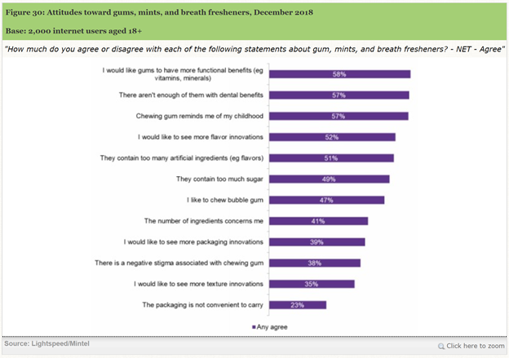

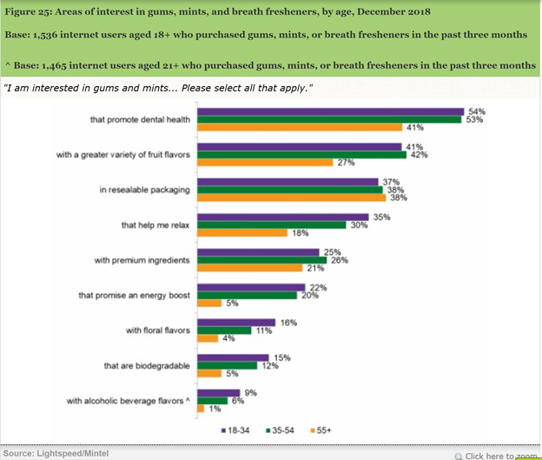

* + Penetrate Oral Care Market
    - The CDC (Centers for Disease Control and Prevention) states oral diseases (ranging from cavities to oral cancer) cause pain and disability for millions of Americans each year. It details how one in four adults has untreated cavities, and 50% of all adults aged 30+ have signs of gum disease. Many health issues particularly exist amount certain population groups including those with less education, lower incomes, and select racial and ethnic groups. Listerine can target these individuals with its already extensive distribution network and provide dental benefits in the gum that satisfy these needs. (Mintel: Oral Health)
    - According to research done by Mintel, more than half of adults drink soft drinks and coffee at least occasionally. Millennials are the core drinkers of coffee based on the research. It also concluded that consumers aged 18-34 are high consumers of regular cola soft drinks.
    - Multiple frustrations exist in the oral care market including the cost of oral care products, time spent flossing, number of steps involved, and time spent brushing. Although Listerine chewing gum will not replace brushing, it can create a more convenient, cheaper, and quicker way to aid in oral hygiene.

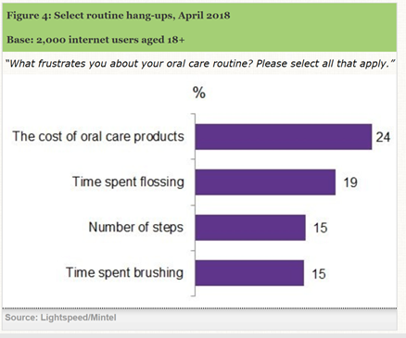

* Leverage Dental Professionals
  + Listerine offers a support program to dental professionals under Listerine Professionals. It is a rewards program with quarterly emails highlighting industry news, product information, and other content to help dentists engage with their patients. Dentists receive free patient samples and patient education resources. (Listerine website)
  + According to Mintel, 47% of those who visit the dentist agree they use product samples given to them during their visit. In addition, 26% of adults who participate in dental visits agree they ask their dentist or hygienist about oral care products. Listerine can continue to leverage dental professionals by having them offer their patients Listerine chewing gum to help fight against gingivitis and other oral health issues. (Mintel)
  + In June 2012, Listerine launched a multipronged marketing effort to promote its mouthwash to oral care professionals. This indirectly drove consumer sales. Johnson & Johnson launched its “Healthcaring” campaign soon after. It determined that dental professionals are the No. 1 driver of consumer trials and the third reason a consumer stays loyal. (Listerine Article)

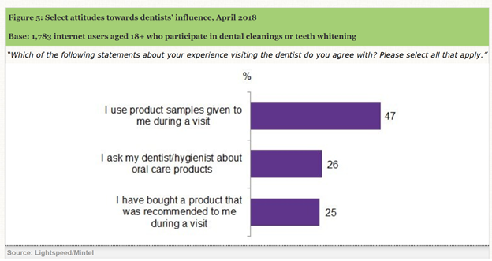

* Threats:
  + Intense Competition
    - Chewing gum is within a highly competitive market, which is primarily based on product quality, innovation, service, brand recognition, loyalty, product launches, effective advertising campaigns, marketing programs and price (MarketLine).
    - In March 2018, Nestle acquired Atrium Innovations, a provider of nutritional health products in Europe and North America. This acquisition is expected to complement Nestle’s health science consumer care portfolio and extend its product range with value-added solutions such as plant-based protein nutrition and multivitamins, and probiotics (MarketLine).
    - Some brands of gum currently use Xylitol, which has cavity-preventing potential; however, this is typically not marketed effectively. Ice Breakers gum is the only competitor who provides insight on Xylitol on its website.
    - Existing competitors may easily be able to offer new gums with similar benefits as Listerine; however, with Listerine’s strong brand and competitive advantage in oral care, this risk is mitigated.
  + Stringent Regulations by the FDA
    - The industry is heavily regulated by the Food and Drug Administration with respect to content, safety, packaging and labeling standards.
    - Compliance is costly and requires the employment of high-skill chemists, technicians and legal experts. (IBIS World)
  + Rising Labor Wages in the U.S.
    - Labor costs in the US have been increasing in the recent past. The tight labor markets, government mandated increase in minimum wages and a higher proportion of full-time employees result in an increase in labor costs. The minimum wage rate in the US remains at US $7.25 per hour. Some of the highest minimum wages in the U.S. include Washington D.C. ($14 per hour), Washington ($12 per hour), and Oregon ($11.50 per hours). Ten others are over $10 per hour. (IBIS World)

**Marketing Objectives**

* Acquire 5% share of the total existing sugar-free gum market in a one year time-frame.
* Make customers aware of the product with oral benefits.
* Effectively use the distribution channels.
* Leverage dentists to promote oral hygiene among US citizens.

**Marketing Strategy**

* Due to the high competition of the chewing gum industry, the goal is to position Listerine Chewing Gum as a gum that offers multiple benefits that current chewing gums do not.
* Benefits will include ant cavity and reducing one’s chances of gingivitis, just as the mouthwash does today. With its strong brand, Listerine Chewing Gum will stand out effectively in an industry that is primarily impulse driven.
* The gum will be shaped in ball form (but soft) and filled with liquid. Although the liquid will not be Listerine mouthwash, it will need to be a safe to swallow and must be marketed as being able to kill 99% of germs with an ADA approval on the packaging. This is a crucial factor due to regulations and competition in the industry.
* A flavor of spearmint will be chosen based on consumer preference.
* Per ADA’s website, 2 out of 3 consumers responded that the ADA Seal on a product simplifies their purchasing decision. Additionally, 71% said they would choose a Seal product over a similar product without the Seal and 69% said they would pay more for an oral care product that displays the Seal (ADA Website).
* There will be three types of gum: Listerine Chewing Gum, Listerine Natural Chewing Gum, and Listerine White Chewing Gum. There will be a 15-piece and a 40-piece product. There will be four target markets:
  + General Public who chew sugarless gum
  + General Public seeking natural ingredients
  + Consumers aged 18-34 who want whiter teeth
  + Dollar Store users
  + Consumers concerned with oral hygiene

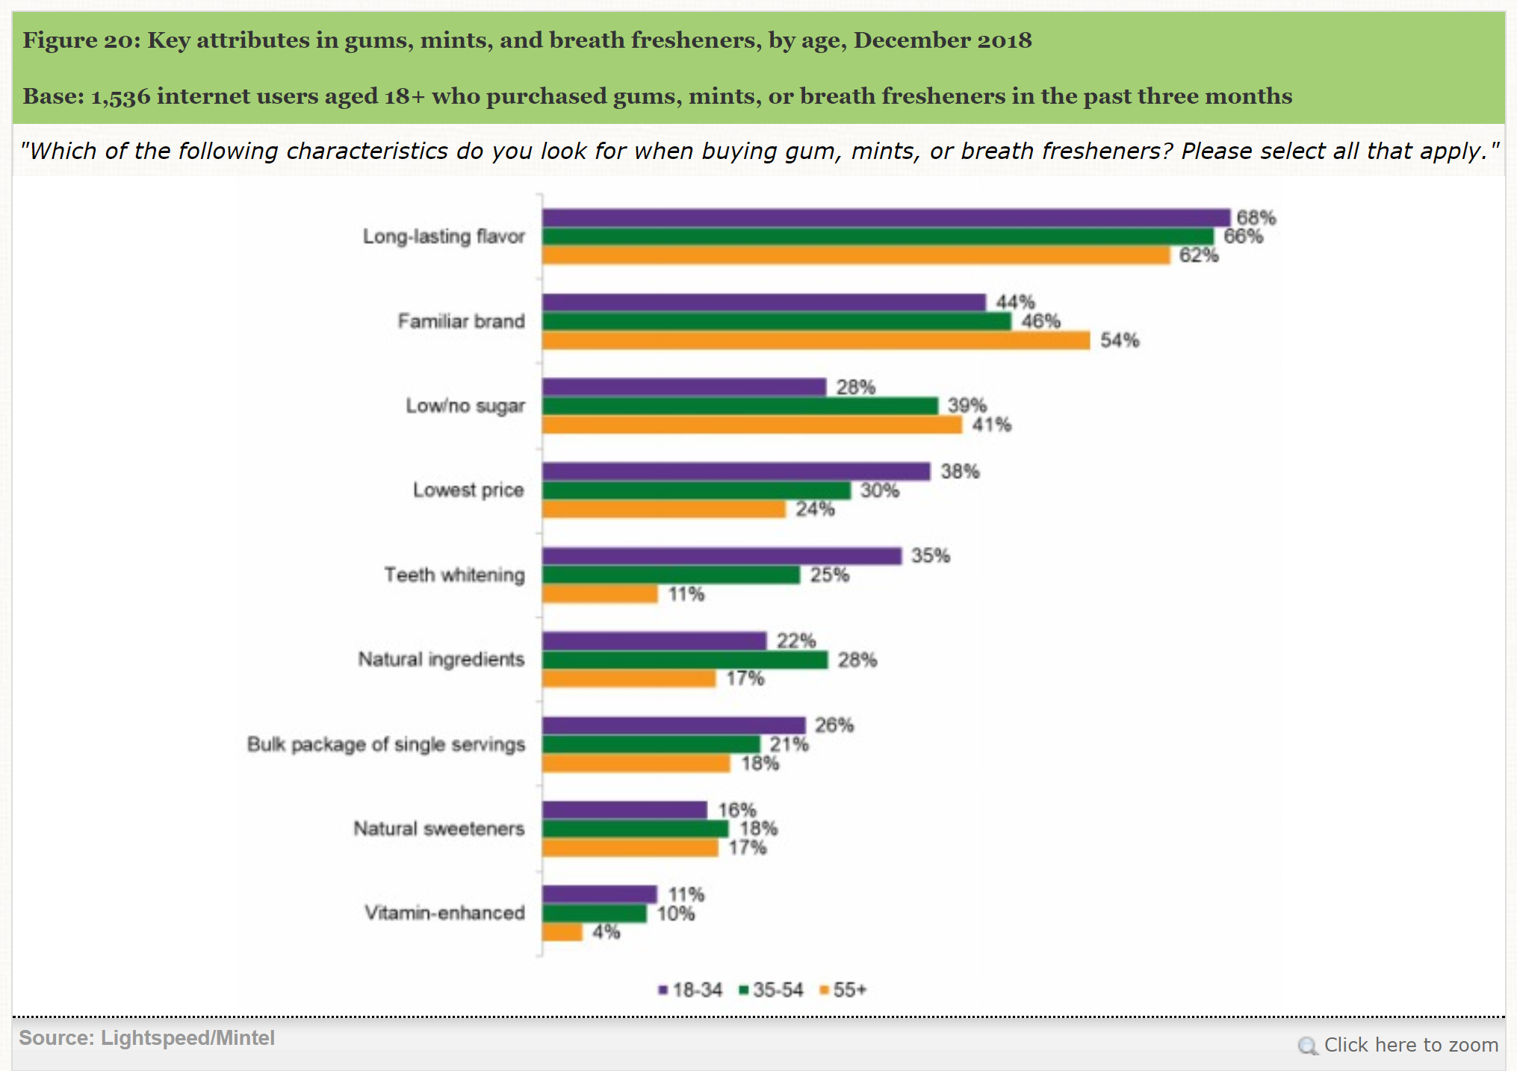

* Target 1: General Public who chew sugarless gum
  + We will target the general public who chew sugarless gum. Although the chart above does not include those below the age of 18, there is still a market for them.
  + This full market approach was chosen due to the impulsive nature of chewing gum and the fact that most products still rely on the benefit of freshening breath. In the eyes of the consumer, there is still a need for dental benefits. Listerine’s strong branding and reputation in oral care is expected to differentiate and position its gum as a provider of dental benefits. There is not a significant market that stands out in the chart above with the exception of teeth whitening which will be targeted toward millennials in a separate product line and explained later.
  + Approximately 61% of parents of children over 18 and 56% of people aged 18+ who are not parents believe there are not enough gums with dental benefits (Mintel). People over the age of 18 are located throughout the country with less concentrations in the Midwest. Given the distribution channels, however, which include major retailers like Walmart, Target, and CVS, a full market approach is still deemed appropriate.
  + Product
    - This market will include the 15-piece and 40-piece packaging. The 15-piece packaging will include the following benefits / packaging:
    - A sealable pouch as this was a factor that was successful for Mentos in the market and consumers responded well to.
    - The pieces will be sphere shaped and wrapped in shiny blue paper.
    - Each piece will be filled with liquid that has similar benefits of Listerine but will be safe to swallow.
    - The packaging will reflect the similar benefits of normal Listerine which includes “Kills 99% of germs that cause bad breath”.
    - Each case will include the ADA seal of approval.
    - The front of the packaging will be blue with the Listerine logo while the back will be clear.
    - All pieces will have long lasting flavor.
    - The 40-piece packaging which include the same features and benefits above; however, the bottle will be shaped like a small Listerine bottle and will be clear with the exception of the logo. The pieces will not be wrapped but will be manufactured so they do not stick together.
  + Price
    - This will be considered a premium product with a strong brand and the ADA Seal. While other gums are priced at $0.09 per piece in retail and $0.06 per piece in wholesalers / online, we will price Listerine gum at $0.12 per piece in retail and $0.10 per piece in wholesalers / online.
  + Promotion
    - This product will need significant advertising due to its full market approach and high competition. Advertising will include social media, television ads, banners, etc. throughout the U.S.
  + Distribution
    - Distribution channels will remain similar to other gums including retailers, wholesalers, online, and others. The maps below reflect different age groups throughout the U.S. All concentrations throughout the country appear similar. Our focus will be on an extensive distribution network to have the same touch points as the competitors.

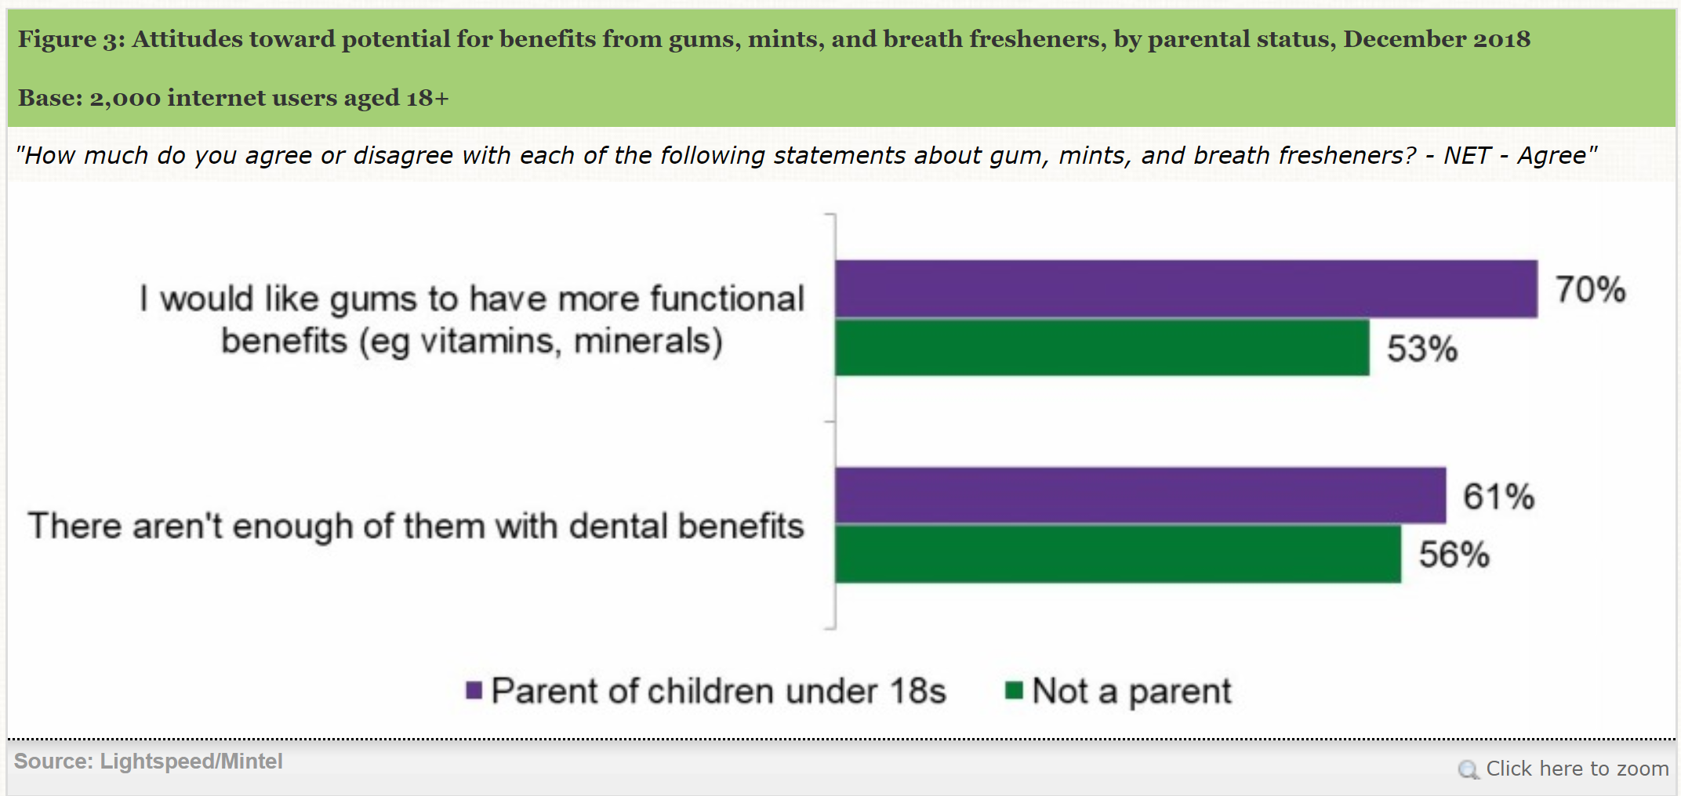

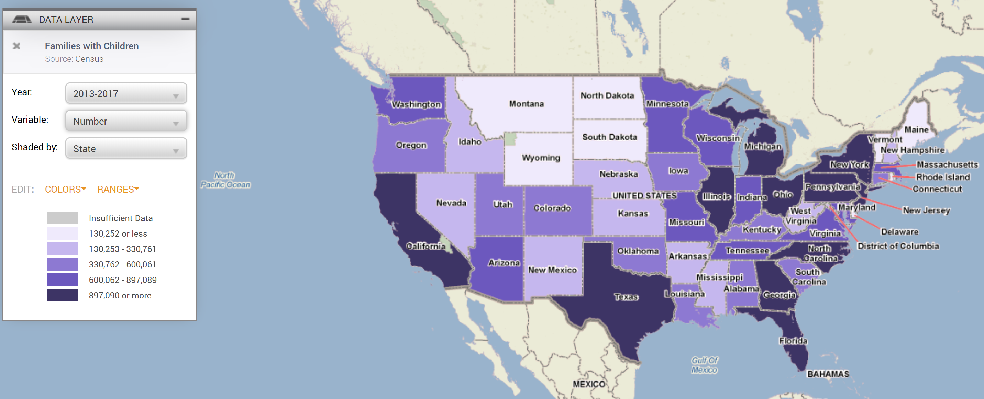

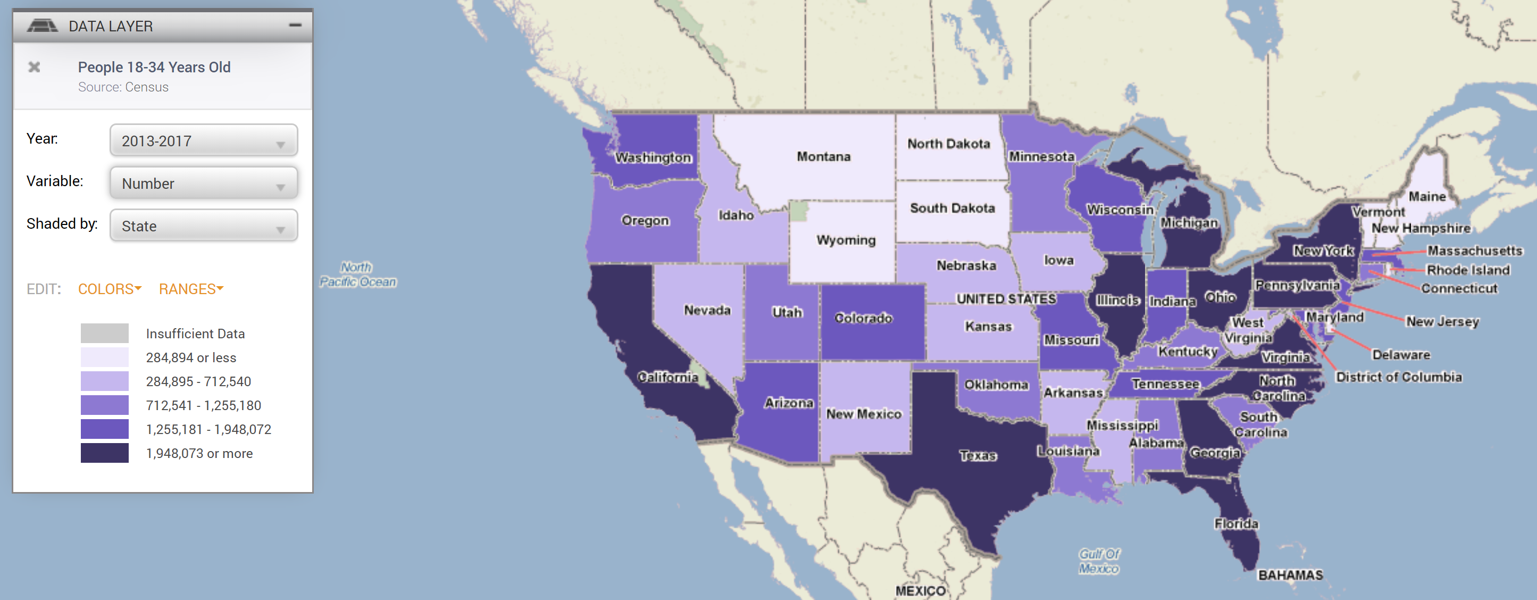

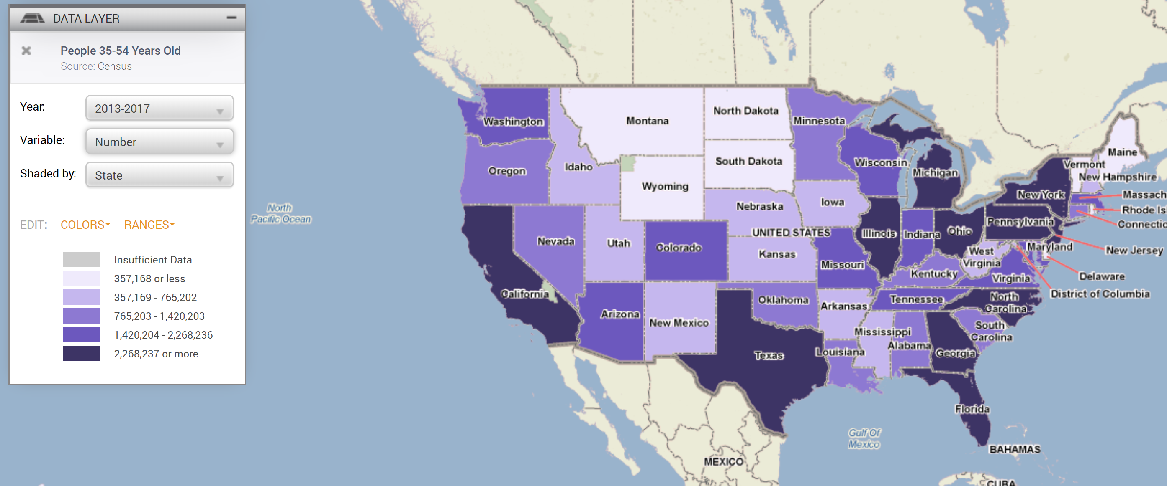

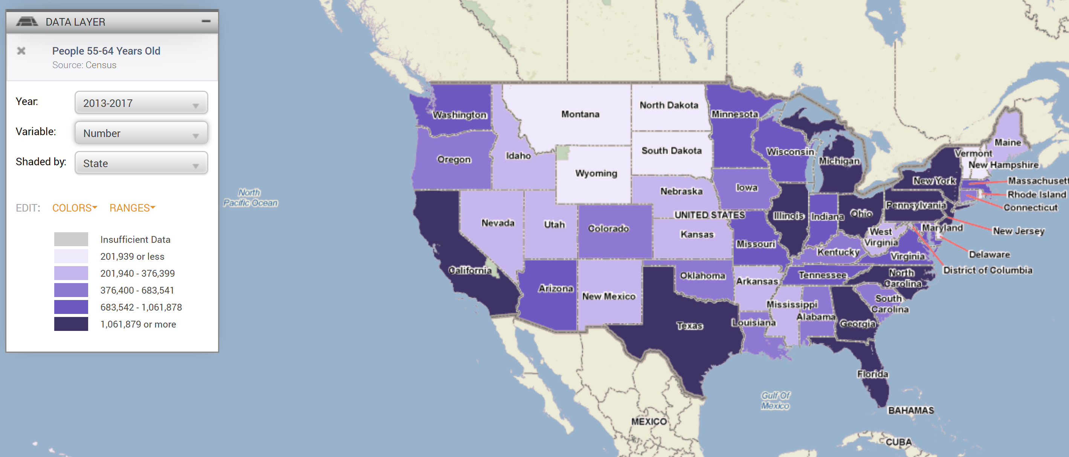

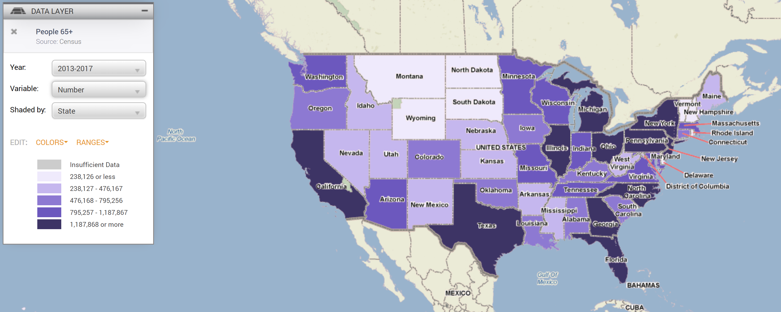

* Target 2: General Public seeking natural ingredients
  + We will also target the general public seeking natural ingredients.
  + Per the table above, consumers aged 35-54 have slightly more interest in gum with natural ingredients compared to the other age groups; however, we still think it is similar enough for a full market approach. A second product line called Listerine Naturals.
  + Product
    - The product will feature all of the same benefits as the normal Listerine Chewing Gum line; however, it will have natural ingredients just as Listerine’s current Naturals mouthwash brand. With the existing technology and competency in place, we believe this will make the product easier for Listerine to develop.
  + Price
    - This will be priced similarly to Listerine Chewing Gum.
  + Promotion
    - This product will need significant advertising due to its full market approach and high competition. Advertising will include social media, television ads, banners, etc. throughout the U.S.
  + Distribution
    - Distribution channels will remain similar to other gums including retailers, wholesalers, online, and others. The maps below reflect different age groups throughout the U.S. All concentrations throughout the country appear similar. Our focus will be on an extensive distribution network to have the same touch points as the competitors.
* Target 3: Consumers aged 18-34 who want whiter teeth
  + We will also target consumers aged 18-34 who want whiter teeth.
    - Per the table above, consumers aged 18-34 have slightly more interest in gum with teeth whitening capabilities compared to the other age groups. A third product line will be launched called Listerine White.
  + Product
    - The product will feature most of the same benefits as the normal Listerine Chewing Gum line; however, it will have teeth whitening benefits just as Listerine’s current Healthy White mouthwash brand and will feature shiny white wrapping and white packaging. With the existing technology and competency in place, we believe this will make the product easier for Listerine to develop.
  + Price
    - This will be priced similarly to Listerine Chewing Gum.
  + Promotion
    - This product will need significant advertising due to its high competition. Advertising will include social media, television ads, banners, etc. throughout the U.S.
  + Distribution
    - Distribution channels will remain similar to other gums including retailers, wholesalers, online, and others; however, this product line will be focused more on the eastern portion of the U.S., Texas, and California.
* Target 4: Money conscious individuals
  + We will target money conscious individuals through a lower overall priced product; however, a similar price per unit.
  + Product
    - The product will feature most of the same benefits / packaging as the normal Listerine Chewing Gum line; however, the overall price will be $1.00 and the pack will feature 10 pieces (or $0.10 per piece of gum).
  + Price
    - This will be priced similarly to retail Listerine Chewing Gum on a price per unit basis.
  + Promotion
    - This product will need significant advertising due to its high competition. Advertising will include social media, television ads, banners, etc. throughout the U.S.
  + Distribution
    - This product will primarily be sold in dollar stores throughout the U.S. Per the map below, this is primarily on the eastern half of the U.S. Dollar stores significantly outweigh other retailers in this segment.

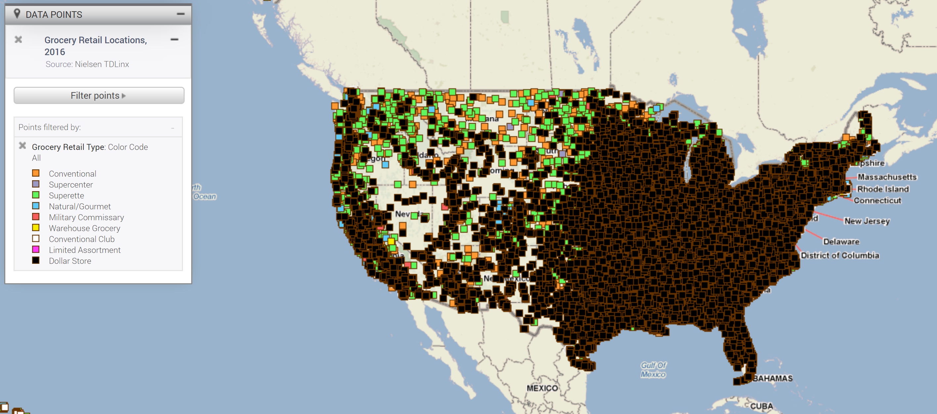

* Target 5: Consumers concerned with oral hygiene
  + We will target the general public concerned with oral hygiene primarily through dentist offices.
  + About 64.7 million adults in the US have periodontitis, with 30% at a moderate stage of the disease, and 8.5% at an advanced stage (Listerine website).
  + By offering samples to dental professionals, we can increase the product awareness. Of those who visit their dentist, 47% state they use products samples given to them.

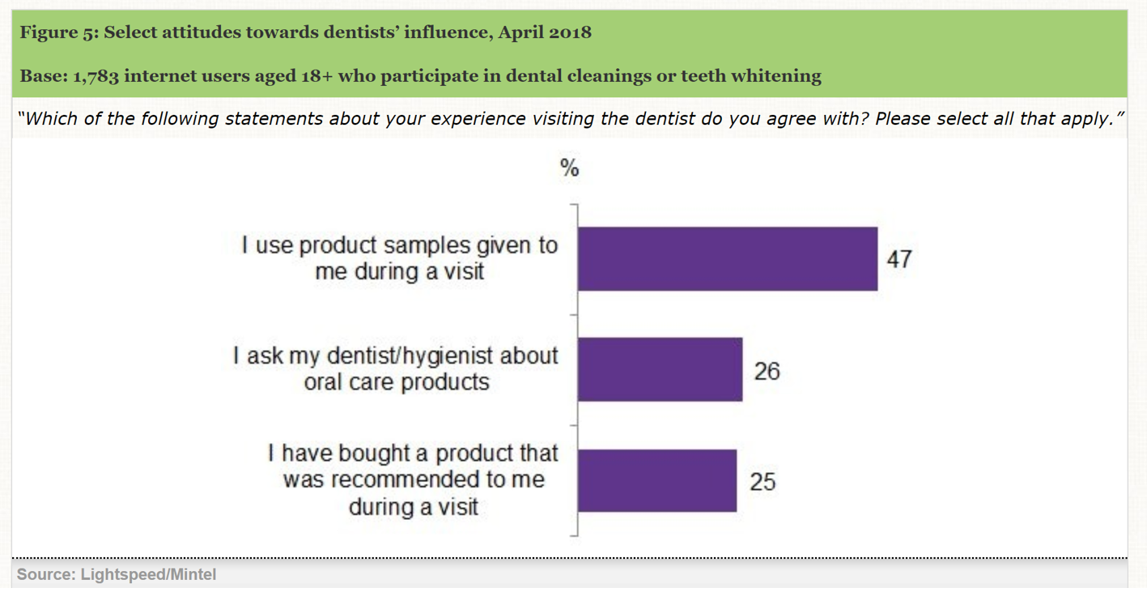

* + Product
    - The product will remain the same as previously stated; however, a sample container that includes 5 pieces will be distributed in dentist offices throughout the country.
  + Price
    - These will be free samples.
  + Promotion
    - The 5-piece samples will be attached to Listerine’s existing bottles and 2-piece samples will be attached to smaller travel size Listerine bottles. The dentists will also promote the product.
  + Distribution
    - The 5-piece and 2-piece samples will be distributed by dentist offices. Listerine currently leverages this network with its existing sample bottles of mouthwash and has proven to be successful in the past.

**Financial Projections**

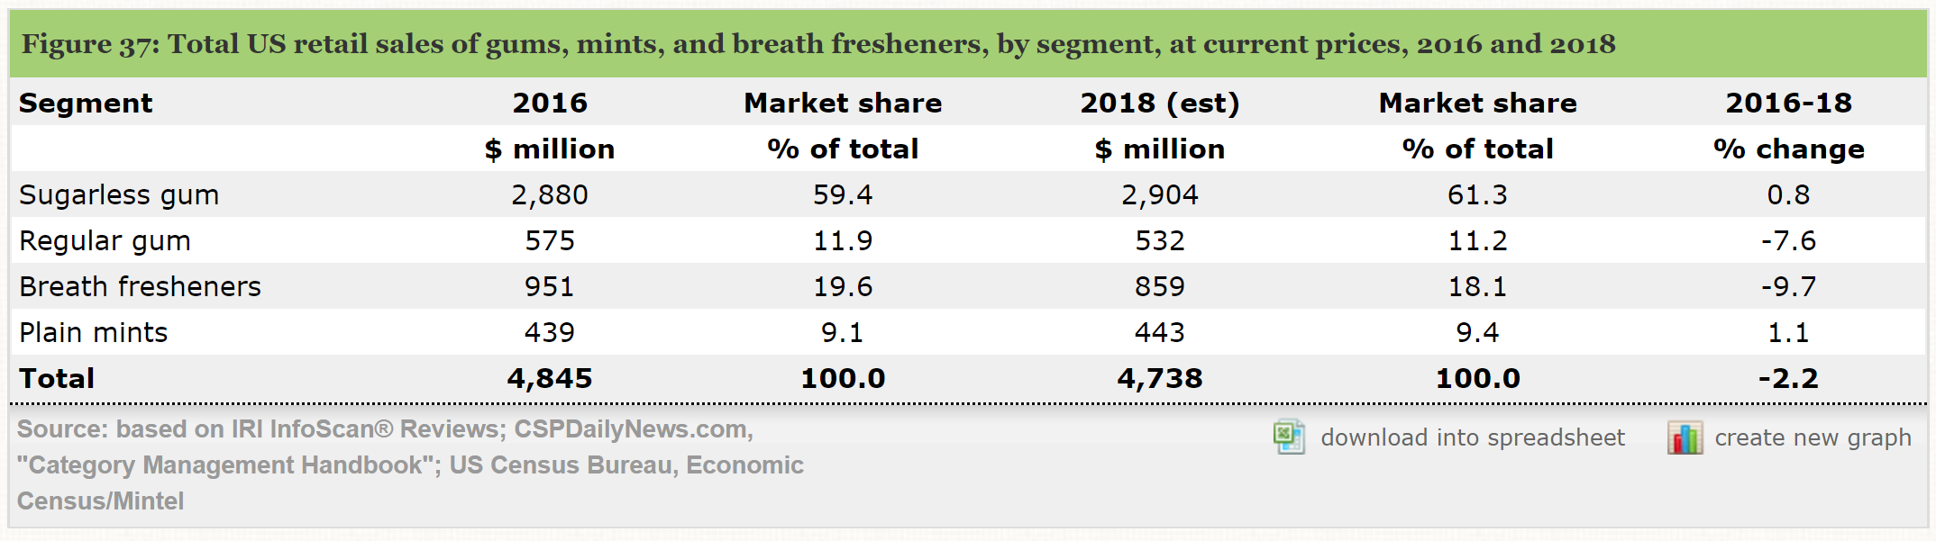

* Total market for gums, mints, breath fresheners: $4,738,000,000
* Total sugarless chewing gum market estimated in 2018: $2,904,000,000 (or 61% of total market)
* A separate source related to IRI, a Chicago-based research market firm reports 2017 dollar sales of $2,549,440,000 at 1,408,000,000 units. This assumes each unit sold for $1.81. Based on 2018 sales of $2,904,000,000, this assumes 1,604,419,890 units were sold in 2018.
* By the end of the 12-month period, we expect to seize a 5% market share in the sugarless gum industry. This equates to approximately $145,200,000 or 80,221,000 units assuming the average of $1.81 per unit still applies.
* The industry expenses are reflected below and derived from IBIS World.

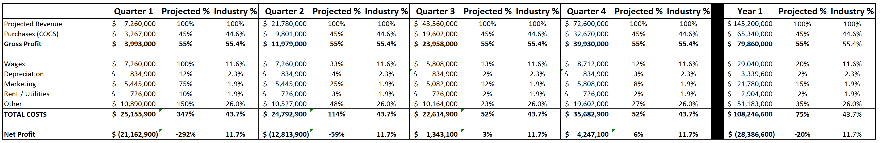

* The table above reflects that in Year 1, we will lose approximately $26 million in profits; however, we will be profitable by the end of Quarter 3. This is reflective of our goal to increase market share as opposed to achieving profitability in Year 1.
* This is primarily due to the high Wages and Marketing costs in the beginning of the year to expose the public to our new Listerine Gum product.
* Wages: This primarily includes the sales reps throughout the year that must market the product to dentist offices and to retailers. With Johnson & Johnson’s existing expertise in this area, we expect these expenses to eventually become more in line with the industry by year end.
* Marketing will remain heavy throughout the year due to Listerine gum being a new product in a highly competitive industry. Competitors are expected to come in with new products once the word gets out on Listerine gum. We will have to keep marketing costs high at approximately 5% of sales to compete.
* Purchases are a significant expense but are expected to be in line with the industry due to Johnson & Johnson’s size and scale.
* Other costs includes overhead such as data processing and communication service fees, R&D, repairs, maintenance, refuse removal, taxes and licenses, and legal fees. In the industry, legal fees have been extensive for some of the largest operators. R&D underpins product innovation and cost control improvements. (IBIS World)

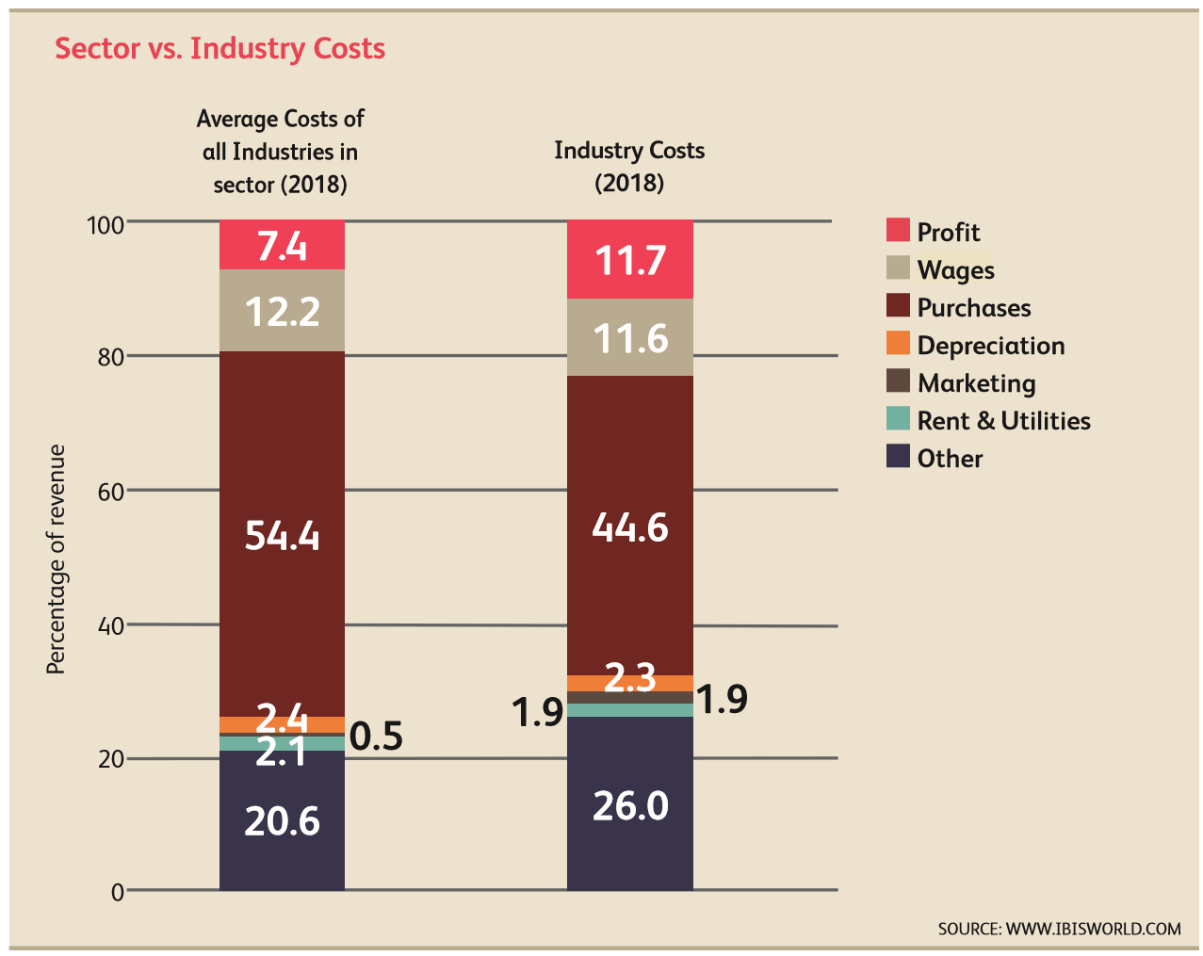

**Marketing Implementation**

|  |  |
| --- | --- |
| **Time Frame** | **Implementation** |
| Month 1 | 1. Develop and manufacture Listerine sugar-free gum.  2. Designing a standard packaging for product line.  3.  Johnson & Johnson announces its product and launches a commercial where the customers are revealed with the new product of Listerine entering the market. |
| Month 2 | 1. Get an FDA approval for the newly developed product.  2. Get ADA seal approved on the product. |
| Months 3- 6 | 1. Make the product available to the market by engaging in different distribution channels.  2. Sales representatives target dentists to recommend and promote the product for oral hygiene.  3. Give 2 & 5 pieces of products free attached to Listerine small & big bottles respectively.  4. Television advertisements,  social media advertisements, digital marketing , banners, posters, etc. |
| Months 6-12 | 1. Focus more on marketing like TV ads, social media, product awareness through dentists and digital marketing.  2. Obtain the feedback from the customers who used free trial.  3. Change some marketing implementation if necessary based on the feedback from the market. |

**Evaluation/Control/Contingency**

* Evaluation of the products performance and its success in the market can be done through analyzing the sales revenue generated by the product over the time frame of 1 year.
* Customer feedback Mechanism
  + For the free trial user we are going to provide a separate link on the package obtained with the Listerine bottles. One can provide his/her feedback for the product by visiting the link and can win cash prize of  $25 for randomly picked top 100 customers who have given the feedback.
  + For Customer who have bought our product through different distribution channels are also given a feedback link where the feedbacks are recorded separately and are awarded with a cash prize of $25 for top 100 Customers.
  + We have two separate feedback for free trial users and the customers who have purchased the product. We can ask for the customer name and contact details during the submission of the feedback form as identification information for them to collect the cash prize if they are selected.  By doing this, we get the data of our customers. With this data we can analyze the geography of the customers and their behavior towards the product. We can also get the customer information who has purchased our product through distribution channels like Walmart, Shoprite, etc. where they have memberships for the customers.
* Performance against objectives can be obtained by analyzing the sales revenue generated by the product over the time frame of 1 year and decide whether it has secured 5 percent share for the total sugar free gum market. Through customer feedback we can make sure that they are aware of products oral benefits.  Data from the distribution channels can tell us the customer base created based on the regions for our product. And dentists can provide us the data of how many customers were suggested to use the Listerine Gum for overall oral care. Considering the feedback from all our leads we can alter or modify our existing plan for the next financial year.
* Potential foreseeable risks associated with our plan are :
  + Competitors coming in the market:  Colgate can come up with their gum similar to ours and could become an alternate for our product in the market. We can mitigate this with strong brand name with huge customer base who are loyal to our brand. By providing more value for our loyal customers.
  + Law Suites: If a person has an injury in his or her mouth and is chewing our Listerine gum we would recommend him or her to see a doctor before chewing. And if he or she feels any irritation or discomfort with respect to his or her health he or she should stop chewing Listerine gum and seek immediate help. If this is not addressed Johnson and Johnson might face Lawsuits and damage its brand.

**Resources**

* www.listerine.com
* Market Line
  + Johnson & Johnson
    - MarketLine. (2019, January 31). Johnson & Johnson: Company profile. Retrieved from MarketLine Advantage database.
  + Wm. Wrigley Jr. Company
    - MarketLine. (2018, June 4). Wm Wrigley Jr. Company: Company profile. Retrieved from MarketLine Advantage database.
  + The Hershey Company
    - MarketLine. (2019, April 2). The Hershey Co.: Company profile. Retrieved from MarketLine Advantage database.
  + Perfetti Van Melle
    - MarketLine. (2019, April 15). Perfetti Van Melle S.p.A.: Company profile. Retrieved from MarketLine Advantage database.
  + Mondelez
    - MarketLine. (2018, November 13). Mondelez International, Inc.: Company profile. Retrieved from MarketLine Advantage database.
  + U.S. Confectionery Industry
    - MarketLine. (2019, February 19). United States – Confectionery: Industry Profile. Retrieved from MarketLine Advantage database.
* Mintel Reports
  + Chewing Gum
    - Mintel. (2019). Gum, Mints and Breath Fresheners – US – March 2019. Retrieved from Mintel Reports Database.
  + Oral Health
    - Mintel. (2018). Oral Health – US – June 2018. Retrieved from Mintel Reports Database.
* Statista: U.S. Confectionery
  + Statista.
* IBIS World: Confectionery Manufacturing
* The Hershey Company 10-K
* Listerine Article
* ADA Website
* Marketing91